Software Design

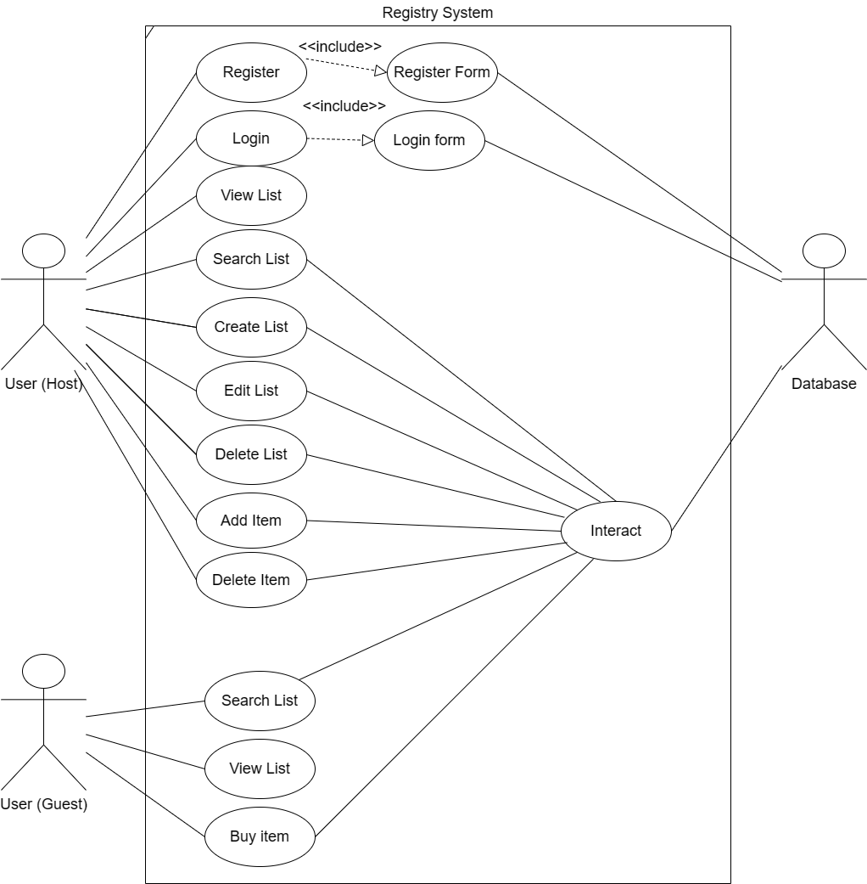

The design that our system uses connects two different types of users (Host and Guest) to the database in a certain way. The User (Host) can Search a List and View a List. To access all the features of the website the User (Host) must register and login. After that they can, Create a List, Edit their List, Delete their List, Add an item to their list, and Delete an Item to their list. The User (Guest) can also Search a List and View a List. Another thing that they can do is mark an item as purchased or not purchased. The reason we have an Interact bubble that connects from the use cases to the database is because those use cases push and pull data from the database.